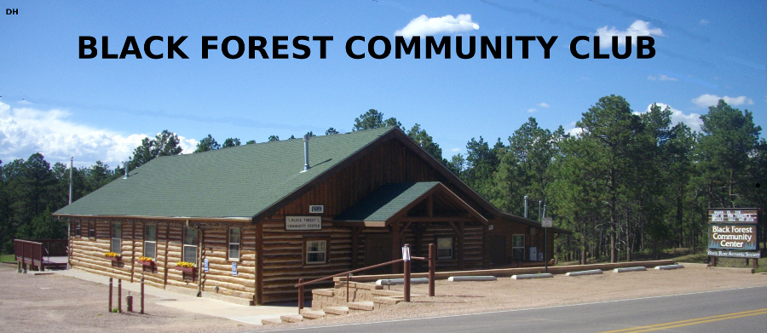

Board and Officer / General Meeting
Thursday, February 27, 2025, at BFCC

In Attendance:

- 16 attendees:
  - 4 BFCC officers
    - James Collins, President
    - Kelly Marchbank, Vice President
    - Cherie Erler, Treasurer
    - John Trcka, Secretary
  - 3 BFCC board members
    - Sherrie Lidderdale, member, 1 year remaining
    - Leif Garrison, member, 2 years remaining
    - Mindy Geiser, member, 3 years remaining
  - 9 club members
    - Chuck Lidderdale
    - Carolyn Brown
    - Don Root
    - Dawn Sciarrotta
    - Johanna Ofstedal
    - Kayla White
    - Steve White
  - No club visitors
    - none

Attachments:

- none

I: Open Meeting

- Jim Collins called meeting to order 6:56pm.

II: Approval of Minutes from Previous Meeting

- All agreed minutes from Jan meeting good with minor exception of a pagination error.
- Leif Garrison made MOTION to approve minutes from Dec and Jan mtgs. Second from Mindy Geiser. Motion carried with all in favor.
- ACTION to John Trcka to add Carolyn Brown to meeting minutes review distribution list
- ACTION to John Trcka to forward approved minutes to Chuck Lidderdale so they can be posted on the BFCC website.

III: Treasurer’s Report

- No comments on report from Cherie Erler.
- Dawn Sciarrotta asked about history of club donations. ACTION to Cherie Erler to provide list of annual donations at next meeting.

IV: New Business

- Concern regarding American Society of Composers, Authors and Publishers (ASCAP) rules for payments from music played that earns money for the BFCC, i.e., the indirect benefit BFCC receives from Black Rose concerts.
- Morgan Hamilton snow removal contract was renewed
- Jim Collins made MOTION to consider the BFCC’s event insurance payment of $300 for the Christmas Gala fundraiser for the BF Log School to be counted as a donation to BF Community Foundation that is normally $200 per year. Second from Leif Garrison. Motion carried with all in favor.
- Backyard update (Steve White)
  - Backyard team met Pikes Peak Regional Building Dept (RBD) for initial land use studies assessment, cost $568
  - Estimating $30K to $40K in required studies, similar to if BFCC was building a new hotel on the site
  - Despite the obvious fact that this lot originally had a 1920s house, well and septic, since the county has no records prior to 1968, RBD considers any work done to be new development with no grandfather clause available
  - Any zoning update could also collaterally impact the adjacent BFCC and Log School lots
  - Likely would need to change zoning from RR5 to commercial, with cost of $4200
  - Well would be considered commercial vice domestic
  - Due to likely unavoidable large costs associated with what county would consider re-developing the backyard lot, all agreed better plan would be to make multiple smaller upgrades in a phased plan
  - no RBD involvement required if
    - upgraded area is less than 1 acre
    - building is < 200 square feet or not enclosed
  - Log School park is <1 acre and 30’x40’ pavilion is open so didn’t require RBD approvals
  - Leif noted that the retainer for landscape architect Kristen Heggen still has hours remaining to be used. She has been a valuable source of information. She has no further need for discussions with RBD.
  - Bathroom facility improvement scope can be reduced with options like a tiny home bathroom or nice-looking port-a-potty within shed as can be seen at local trailheads
  - Jim Collins made a MOTION to down-size backyard plan such that no El Paso County or RBD involvement is required. Second from Sherrie Lidderdale. Motion carried with all in favor.
  - ACTION to Steve White and Backyard committee to down-size, rescale the plan
- Black Rose Acoustic Society request for air conditioning (Jim Collins):
  - This will be BFCC’s next big expense, but Black Rose will likely be very generous with sharing the cost – estimating at least 50%
  - If add air conditioning, will also look at heating update (will likely be required by RBD permit to ensure up-to-code)
  - Don Root noted that the currently heating system is likely 50 years old and is due for failure / replacement soon.
  - Jim Collins noted that there is already 4” of insulation between ceiling and roof which will reduce HVAC load/cost.
  - Jim Collins noted that modern ‘mini-split’ HVAC systems need no ducting which will reduce installation cost and visual impact.
  - Chuck Lidderdale noted that an insulating layer in crawlspace would improve the HVAC system efficiency, and should be included in future quotes.
  - Jeff Ader (not present) has also noted that many of the rental customers have asked for air conditioning improvement
  - ACTION to Jim Collins to get two or three quotes for this service
- Black Forest Business Connection update (Jim Collins):
  - This org led by Marissa Searle was authorized at January’s meeting to meet twice per month in mornings at BFCC at no cost.
  - Jim recommends we let them have one monthly meeting in evening to help with their attendance. All agreed this was a good idea.
  - Jim recommends we host a once per year dinner for this group as a way to say thanks and to support our local businesses that have done so much to support BFCC in the past. All agreed this was a good idea.
  - Cheri Erler noted that BFCC bylaws prohibit a commercial entity as a member given our non-profit, social club tax favorable status
- Easter event update (Mindy Geiser):
  - Local businesses being helpful: Firehouse on the Run, Mountain View Café
  - Working to get local youth groups involved: 4-H
- Dawn Sciarrotta proposed we form a new Kitchen Maintenance committee to organize once or twice per year kitchen clean-up day
- Black Forest Fire & Rescue leadership update (Jim Collins):
  - This org is going through significant leadership change and is looking for community input on their way-forward
  - Jim recommends we all get involved and spread the word on this important issue to ensure our emergency services quality is not reduced
- Welcome committee update (Jim Collins, Christy Collins not present):
  - Considering including a small gift in welcome letter, e.g., a pen or magnet. More to come on this at a future meeting.

V: Close Meeting
- Sherrie Lidderdale made MOTION to close meeting. Second from Leif Garrison. Motion carried with all in favor.
- Meeting adjourned at 8:24pm.

